**Minutes from St Monica’s AGM for 2019/20 30th of November, 2020.**

|  |
| --- |
| **Location**: Nest Cafe, Walkerville |
| **Date**: 30th of November, 2020 |
| **Time**: 7:10pm |
| **Attendees**: Attached attendance sheet Appendix 1. |
| **Apologies**: Trish Cain, Megan Gillett, Kristen Ryan, Debbie Crowhurst. |
|  |

|  |  |  |
| --- | --- | --- |
| Action items | Responsible | Due |
| 1. Meeting opened at 7:10pm | - | - |
| 1. Welcome – Judith Lukas, President | - | - |
| 1. The minutes from the last AGM, have been circulated and approved by the quorum. No Business arising.   Moved: Claire Brooks  Seconded: Amy Thomson |  |  |
| 1. Correspondence in: No Correspondence   Correspondence out: Notice of intention to hold 2020 AGM  Notice of Date Amendment |  |  |
| 1. Treasurer’s Report   The Profit and Loss statement, Balance Sheet and auditor statement was provided to all members attending the AGM and will be made available online.  Income was significantly lower than previous years but so were our total expenses and resulted in a profit for the 2019/2020 financial year of $7,308.24.  This profit is considerably better than average partly due to the Winter affiliation fee payment being delayed until the 2020/21 financial year.  It is predicted that the 2020/2021 financial year will be a loss due to the Winter fee discount offered has mostly been refunded in the 2020/2021 financial year plus there will be 3 x affiliation fees included in the expenses.  Reports Attached Appendix 2.  The Treasurer’s Report was approved by the meeting.  Moved: Annabel Marsh  Seconded: Anisha Prasad  Motion- Moved by Michelle McGuire  Seconded Corina Renney  **Motion carried** | - | - |
| 1. President’s Report - Appendix 3. |  |  |
| 1. The SMNC Constitution requires that each committee position held, is to be retained for a 2 year period, unless the incumbent resigns.  **Even Year Positions up for nomination include:**   **President - 2 years**  **Amy Thomson nominated Judith Lukas, seconded by Tricia Howard**  **Position accepted**  **Vice President – 1 year to run due to Position Vacant**  **Tricia Howard nominated Amy Thomson, seconded by Claire Brooks**  **Position accepted**  **Secretary – 2 years**  **No nominations received –**  **Umpire’s Coordinator – 2 Years**  **Emily Craft nominated herself, seconded by Natalee Swansson**  **Position accepted**  **Equipment Manager – 2 Years**  **Tricia Howard nominated herself, seconded by Claire Brooks**  **Position accepted**  **Uniform Coordinator – 2 Years**  **Natalee Swannson nominated by Judith Lukas, seconded by Claire Brooks**  **Position accepted**  **4 Other general Committee positions:**  **Anisha Prasad nominated herself, seconded by Claire Brooks**  **Georgia Cooymans nominated herself, seconded by Elli Valente**  **2 positions remain vacant**  **The signatories for the coming year will be:** President – Judith Lukas  Treasurer – Claire Brooks  Vice President – Amy Thomson | **Email club members** | -  -  -  This week  -  -  -  - |
| 1. Meeting closed at 7:45pm. |  |  |

These minutes were approved by

St Monica’s Netball Club Committee:

St Monica’s Netball Club Secretary Date

**Appendix 1.**

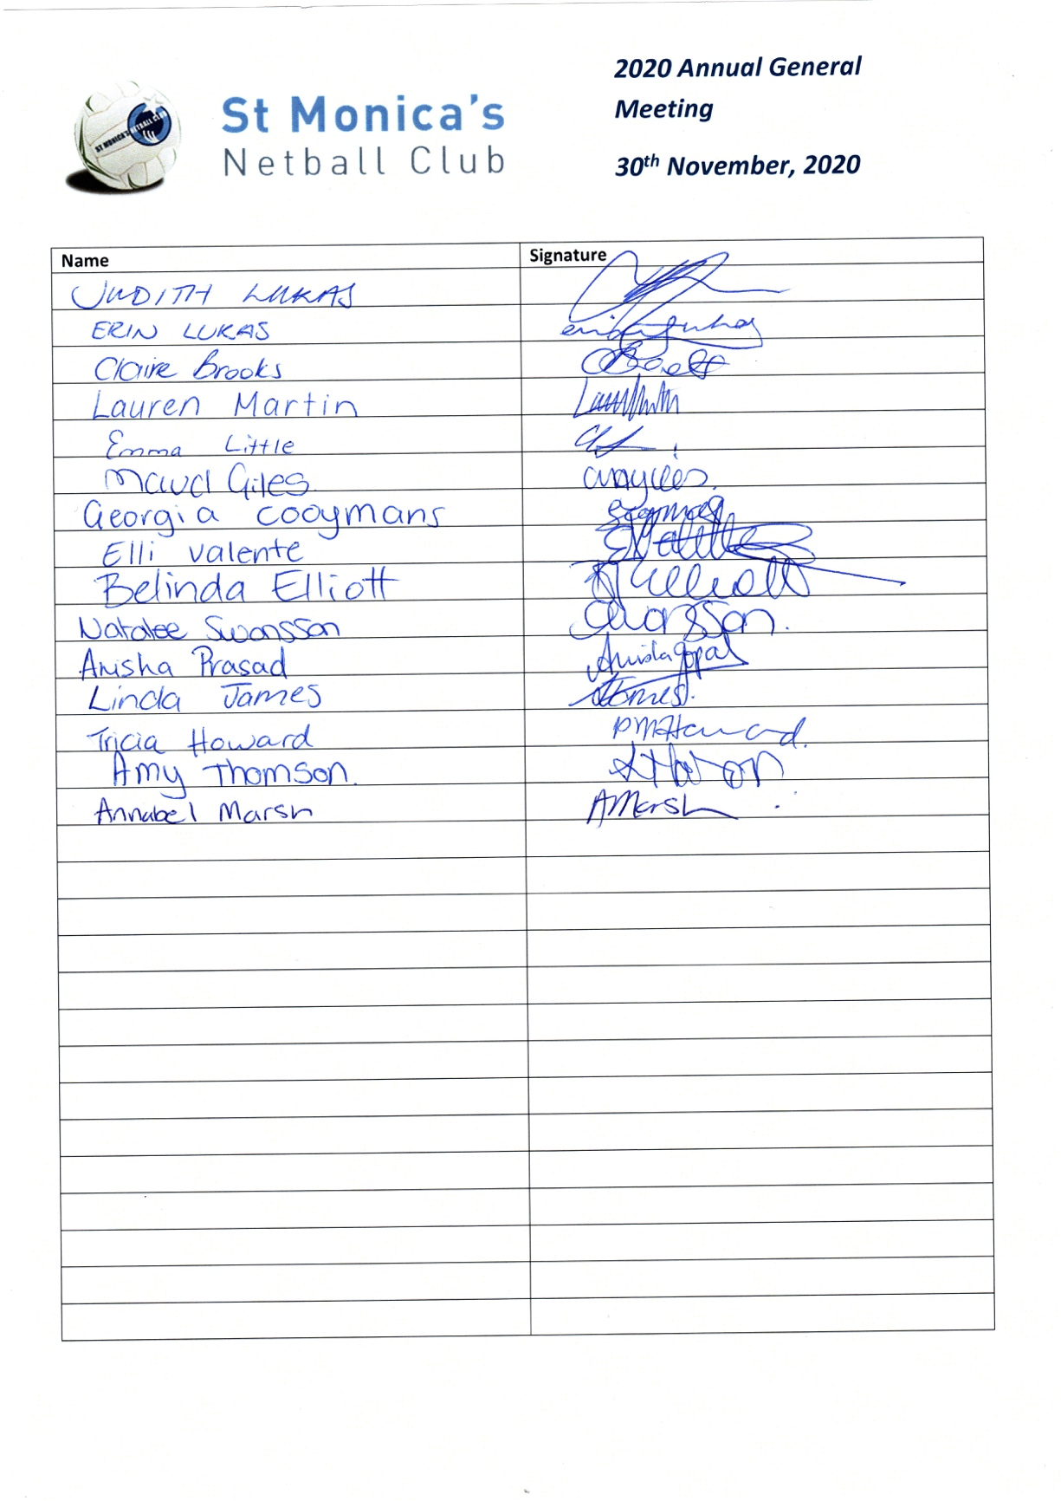

**Appendix 2.**

**profitLoss%201.7.19-30.6.20.pdf**

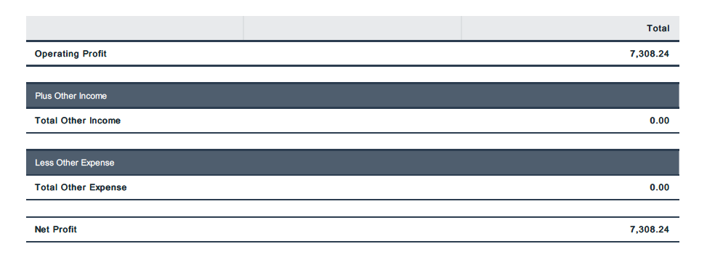

**balanceSheet%2030.6.20.pdf**

**St%20Monicas%20Netball%20audit%20opinion%202020.pdf**

**Appendix 3.**

President’s Report 2019-20

Wow what a year!

The last 12 months has presented us with unique challenges.

As a club I would say we have done a brilliant job managing with all the restrictions of COVID.

This situation has seen both the government and the council look to invest strongly to support local sporting organisations.

We have received quite recent notification that we have been successful in receiving both a State Government Active Club Grant of $2,550.00, and a grant from City of Port Adelaide Enfield Council of $450.

The Active Club Grant can be spent on equipment, and the council grant is to support a further Have a Ball introductory program.

We will be asking coaches for ideas about equipment they see that would be useful.

We will look to get a new ball pump, and additional team bags.

I have been working with the council for some time now on the proposal to upgrade the lighting at the courts to give us 3 of 5 courts with lights, and I’m excited to say this work will be completed in January, so next winter we will be able to have multiple teams training with lights. There is also a plan to upgrade the carpark to include more parking, and to bituminize the surface. There has also been some discussion about us taking on the lease of the clubrooms, there are pros and cons for this, but I’m yet to see the figures from the council although I have asked them for the information again.

Netball post sleeves have been replaced with sleeves with integrated caps, and hopefully the tennis post sleeves will also be replaced in due course.

We had a small fall in the number of winter teams, largely due to fewer seniors nominating, even after all the work to promote the senior side of the club in a social sense. Summer is much more popular with senior players.

Juniors has also seen a modest increase in numbers.

The short winter season saw 5 teams, finished in the 1st or 2nd spot, play in the final, and 2 of those teams won their Division, U11(quite a few new to netball) and & U17.

As a club some constant challenges confront us: having enough umpires, and meeting expectations of juniors and their parents around grading and team selections, and coaching.

We experience the competing desires of remaining with friends (or the existing team) and the wish to play as competitively as possible. I think we do very well for the large portion of our players, however when we move into U13 and U15 and U17 and the numbers fall away we are not always able to offer a range of teams at the range of skill levels that we would like, and we have teams that can include players with a diversity in skill, and experience.

I don’t really know the answer to these challenges, we can only keep trying and ask that everyone respects that we are trying our best.

I want to thank all our coaches for the fantastic job they do, and our loyal group of umpires headed by our Umpire’s Coordinator Emily Craft, and all our dedicated committee – we have had very few meetings this year, and there is a lot of business we can manage via email, or manage electronically, I thank you all for your dedication to our club, and the way you provide me with support.

But I must single out Claire Brooks for special mention, Claire does a lot of work in contact with our members, as a coach, and in the background, and we are often in daily contact on matters to do with netball, we are fortunate to have her efficiency and personally I could not do the job of President without her input. Thank-you Claire.

Judith Lukas