Minutes for St Monica’s AGM for 2020/21 13th of September, 2021.
Location: Nest Cafe, Walkerville
Date: 13th of September, 2021
Time: 7:00pm
Attendees: As per Appendix 1.
Apologies: Tricia Howard, Debbie Crowhurst, Georgia Cooymans; Mojgan Yodegary, Maud Giles, Miranda Centofanti, Sallyanne Bristow, Marissa Watkins

Action items | Responsible | Due
- Meeting opened at 7:02 pm | - | -
- Welcome – Judith Lukas, President. Welcome to members including our Honorary Life Members Patricia Cain and SAUCNA President and HLM Mark Walker. | - | -
- The minutes from the last AGM, have been circulated and approved by the quorum.

Moved: Claire Brooks

Seconded: Annabel Marsh
- Correspondence in: No Correspondence
Correspondence out: Notice of intention to hold 2021 AGM

- Treasurer’s Report
We have had a very successful financial year considering my projection of a loss for the year due to having the expense of 3 x affiliation fees, plus the refund of a portion of the 2020 Winter fees due to the discount offered because of the shorter season.
Our profit of $3,565.57 is mostly attributed to the grants totaling $3,000 we received from ORSR and Port Adelaide Enfield Council.
My forecast for the 2021/22 financial year is positive and I see no reason that we won’t operate with a profit.

Judith’s comment – as we have not put fees up for the last ~3 seasons, although there have been increases in SAUCNA fees, in effect has been a reduction in fees to players, with no effect on recurrent bank balance.

Reports Attached Appendix 2.

The Treasurer’s Report was approved by the meeting.

Moved: Anisha Prasad

Seconded: Annabel Marsh
- President’s Report - Appendix 3
- The SMNC Constitution requires that each committee position held, is to be retained for a 2 year period, unless the incumbent resigns.  Odd Year Positions up for nomination include:  Vice President –  Amy Thomson, nominated by Natalee Swansson – declined.  Phil Dalton nominated by Judith Lukas, seconded by Amy Thomson, accepted. Elected unopposed.  Secretary –  Jodie Shoobridge self nominated, seconded by Claire Brooks. Elected unopposed.  Treasurer – Claire Brooks self nominated, seconded by Natalee Swansson.  Elected unopposed.  Score Recorder – Alana Dowdell nominated by Judith Lukas, seconded by Christel Crowther. Judith will check with Alana prepared to continue.  Elected unopposed.  Website/Social Media – Judith to check if Elli will continue with the role of social media  Coach Coordinator –Tash Holmes self nominated, seconded by Amy Thomson. Elected unopposed.  President – 1 year to run Judith Lukas  Umpire’s Coordinator – 1 year to run Emily Craft  Equipment Manager – 1 year to run Tricia Howard  Uniform Coordinator – 1 year to run Natalee Swansson  4 Other general Committee positions: Kelly Nicholls, Anisha Prasad, Linda James, Amanda Simcock, Christel Crowther.  The signatories for the coming year will be:  President – Judith Lukas  Treasurer – Claire Brooks  Secretary – Jodie Shoobridge  Vice President – Phil Dalton | Judith  Judith
- Meeting closed at 7:27pm.
These minutes were approved by
St Monica’s Netball Club Committee:
St Monica’s Netball Club Secretary Date

Appendix 1.

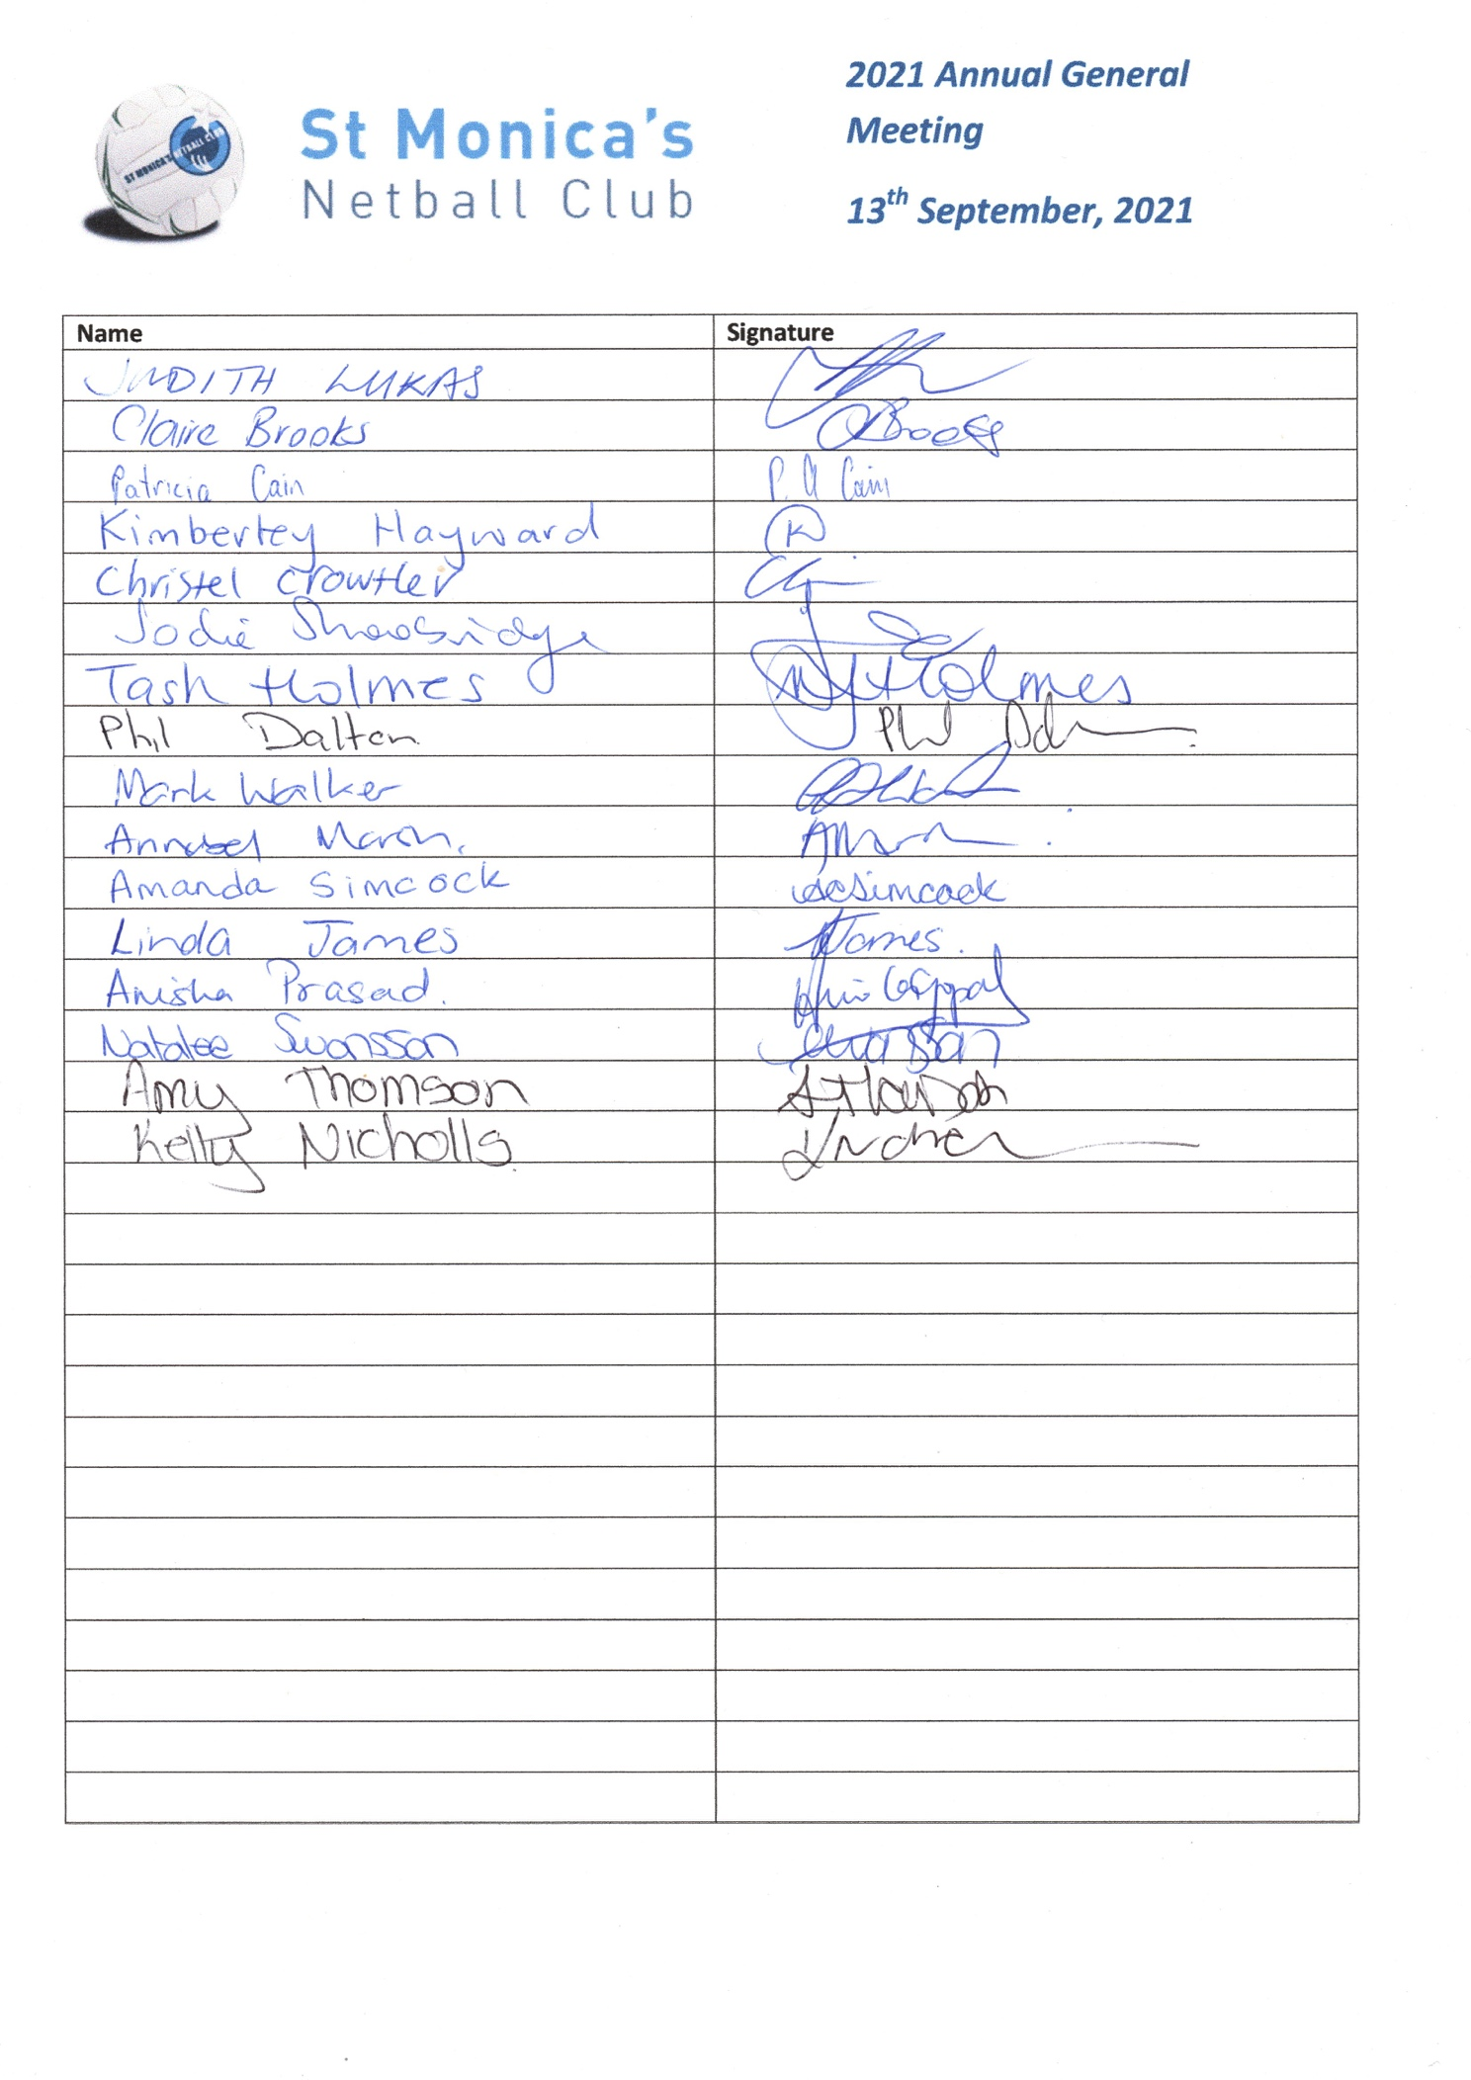
Appendix 2.

Appendix 3.
President’s Report AGM 2021
The past year has seen continuing COVID challenges become our new norm.
We have responded to these very well, and will continue to do what we need to. Our Junior Presentation has showed how we can change and perhaps deliver an improved outcome.
The likelihood of large sections of any given season being lost to lockdown is increasingly unlikely.
However, management of the club does need to take into consideration the loss of players, umpires or coaches, at any given point of time, with as little as a sniffle. The prospect of this occurring with umpires is the most challenging situation to manage.
Umpiring and availability of umpires must remain our principle objective to improve upon, outside of our day to day activities.
The winter season was a success with three premierships from 14 teams, and all teams, players and coaches, are to be congratulated on their hard work.
It was very pleasing to see COVID has not dented juniors desire to play netball, and 4 teams in both U11, and U13 has to be seen as a very promising sign.
Increasing team numbers in age divisions enables us to have the range of teams to satisfy the range of skills of players wanting to play.
Expanding the number of teams in U13s then protects us from the High School drop off that occurs between U13 and U15. Ideally we want more than just 1 or two U15 teams and we know from past experience when we had 1 or 2 we can’t adequately provide for the skill requirements that players by this age are likely to need. Nonetheless as a community based club, I would hope that we could always offer teams to players who may not have played before, but would like to have a go.
Our clubrooms, home courts, carpark and lighting have all had a very long overdue upgrade.
In the past two weeks the tennis post holes have been replaced.
Discussions again have been initiated by council about us having a permanent lease at the club, rather than the current seasonal hire arrangement, this has happened a number of times, and then nothing has been forthcoming from the council. What this means is still not 100% clear, but would mean generally is other users would hire from us, and we would charge accordingly, and we would have certain obligations around maintenance at our cost, and some charges would come directly to us (electricity). I do have my own reservations, time to manage other users access, increased costs in some respects might be outweighed in others, and as I said to council, more than once the devil is in the detail and until we see it in writing, we can’t decide what is best for us.
Watch this space.
I want to thank everyone on the committee for their hard work for all the things we do, people are always prepared to help.
From the start of the year with sorting players and holding selection trials for U13, and U11, this is never easy, but I think when we do get the chance to reflect on 3 wins from 8 teams, we have to think we did pretty well. Claire for her amazing organising of everything, Amy and Tricia for their work on selections, and all three on ongoing operational matters, and Annabel as Coach Coordinator.
Coaching development session - Thanks Amy. Minutes - thanks Amy!
Alana Dowdell for her score entering support.
Team Photos – Amy and Claire. These were great and especially good to use for our Presentation.
Very big thanks to Annabel for her input as the coach coordinator, you will be missed now Cece has moved on from netball.
Natalee, uniforms – what a big headache this year, thanks for your help.
Equipment kits for training – Tricia.
Have a Ball – Emily Craft, Carleigh Bruin, Nicoletta Mihelios, Piper Drawwater.
Umpiring – Emily Craft – and all our umpires young and old, never a dull moment. So excited to see Piper Drawwater being selected to umpire finals although still in her orange armband year. Thanks to Sam Hutchinson who umpired so much at the end of the season, and saved me from having to forfeit 3 Open teams after Lorraine Natt’s father died, and Emily was in quarantine. And for umpiring so well for SAUCNA during the finals, umpiring A1 and A2 finals games – such a valuable young umpire.
Thanks to everyone for making Presentation such a success. Melissa Rees for the venue suggestion, and manning the bar all afternoon, and making it all so easy to be a big success, and all the committee and parents for set up help and the prizes that made the raffles lots of fun. And the girls themselves who are a delight to know.
Judith Lukas

