Coach & Team Manager’s
BOOKLET

WINTER 2023

Contents
St Monica’s Netball CLUB 4
Who we are 4
Our Philosophy 4
Our Players 4
How we work 5
This document 5
RULES of the GAME 6
RULES of PLAY - SAUCNA 6
FIXTURES 6
Coaching Resources and Support 7
On the Court (WINTER) 7
COURTS 7
Playing at Home 7
On the Court (SUMMER) 8
COURTS 8
Court Time 9
Fill in Players 9
FILL-INs 9
FORFEIT 10
REGRADING 10
RESULTS 10
Score Cards and Scoring 10
WINTER GAMES (Home & Away courts) 11
SUMMER GAMES (Association Courts) 11
SCORERS 11
Bibs 12
Umpires 12
Court Behaviour 13
Incident Reporting 13
Codes of Conduct 14
Supporting positive team behaviours 14
COACHES RESPONSIBILITIES 17
Child Safety – Coaches and Managers 17
Team Organisation & Management 18
Primary Care Giver 18
Working with Parents 19
General information 19
Training and games 19
Health & Safety 19
Knee program 19
First Aid 19
Concussion 20
Insurance 20
Club Awards 21
BEST & FAIREST PLAYER 21
TEAM PLAYER 22
PERPETUAL TROPHIES 22

St Monica’s Netball CLUB

Who we are

St Monica’s Catholic Parish Netball Club Inc. is a community-based netball club located at Laurie Knight Reserve, Romilly Ave, Manningham.

We compete in the South Australian Uniting Church Netball Association (SAUCNA), an association supporting netball for all ages in Adelaide, South Australia.

Our Philosophy
We promote healthy living, sportsmanship, teamwork, fun and friendship, through affordable and inclusive netball. The club strives to support all players, coaches, and umpires to reach their full potential, and achieve a positive netball experience as a member of the SMNC. We are committed to the provision of a child safe environment.
We seek to:
- lead by example
- respect all involved in the sport of netball
- play hard; and have fun.

Our Players
The St Monica’s Netball Club, SMNC, enters teams in U8, U9, U11, U13, U15, U17, and Open divisions of SAUCNA competitions in winter and summer seasons.

We also offer an introductory Netball program called “Have a Ball”, for children 5-7, during the winter season. The program introduces netball skills and the concept of team sport to juniors, prior to their first experience playing in a netball competition.

How we work
Our club is managed and supported by parents and guardians on a voluntary basis. This commitment has sustained this club for over 50 years!

Involvement in the club carries with it the expectation that players and guardians offer some time to assist the club to support our players. Therefore our volunteer committee appreciate opportunity to share the load, and encourage parent participation on the committee, managing teams, coaching, helping out at the Saturday BBQ’s, assisting with uniforms, help out with working bees, fundraising, helping out for formal presentations, or any activity the club needs to do to ensure the players have a wonderful netball experience. Without the assistance of volunteers the club would not function. As a coach, your contribution is highly valued.

This document
This document is a guide to most things a coach or manager may need to support your team for the upcoming season. Coaches and team managers are responsible for guiding the team and parents regarding expectations of them, and each other, throughout the season, from enhancing understanding of the rules of play, to your expectations of them as a coach, and to reinforce expected behaviours on and off the court, for players and spectators alike.

There are many links throughout the document where more detail is required. Direct links ensure that you have access to the most up to date information.

In the interests of conservation of paper and material resources, and changes in electronic management of documents, we will increasingly share documents used for your use and reference in electronic form, where you can print if and when required. To assist you, any materials required by the committee for the reporting the game (eg voting slips, score cards, etc) will still be provided in hard copy.

RULES of the GAME
Rules of the Netball game are as per the INF Official Netball Rules.

RULES of PLAY - SAUCNA

The SAUCNA Playing Regulations combines various bylaws and conditions that inform the competition including player and parent behaviour, discipline policies and association amendments to the INF 2020 Rules of Netball applicable to SAUCNA.

The SAUCNA fixtures can be found at www.saucna.net/ Competitions.

Weather:
Adverse weather conditions and the cancelling of matches is as per the SAUCNA Playing Regulations/Playing conditions.
WINTER - Play is generally expected to continue in the event of wet weather.
SUMMER - Conditions of Hot Weather will be notified on the SAUCNA Facebook page by no later than 4:30pm on game days.

FIXTURES
Our Association, SAUCNA have listed the fixtures and ladder on the Play HQ website. Use this site as your reference point and direct your teams to do the same.

https://www.saucna.net/

or by logging into:

https://www.playhq.com/

The fixture shows the round number, date, opposing team, court number, and the team letter
or identifying name of the team.

The first team listed is the “HOME TEAM”, the second team is the “AWAY TEAM”.

Coaching Resources and Support
The club makes coaching resources available for all coaches for free. Coach development is considered an important strategic goal within our club.

Attending SAUCNA or other coaching courses will be financially supported. Resources for coaches can be found on our website: http://stmonicasnetballclub.squarespace.com/coaching-resources

The Netball Coaches Handbook (Winter) is emailed to all coaches prior to the beginning of the season. The booklet provides additional guidance regarding how to record each game, including game date, opposition, positions played each quarter, and offensive or defensive statistics. This handbook is valuable for checking fair court time, player position rotations, to review performance against opposition teams.

The handbook allows for the capture of goal scorer statistics to assist coaches/managers to recommend players for the Goal Scoring Trophy. An assessment of scoring accuracy will be required to assist nomination for our end of season awards.

On the Court (WINTER)

COURTS

Playing at Home
St Monica’s Netball Club courts are at Laurie Knight Reserve, 33/21 Romilly Ave, Manningham. Winter season is primarily conducted at the home grounds, for U8-U15s.

Teams and spectators should be positioned at the home courts as per the diagram below (The example shows three games in progress):
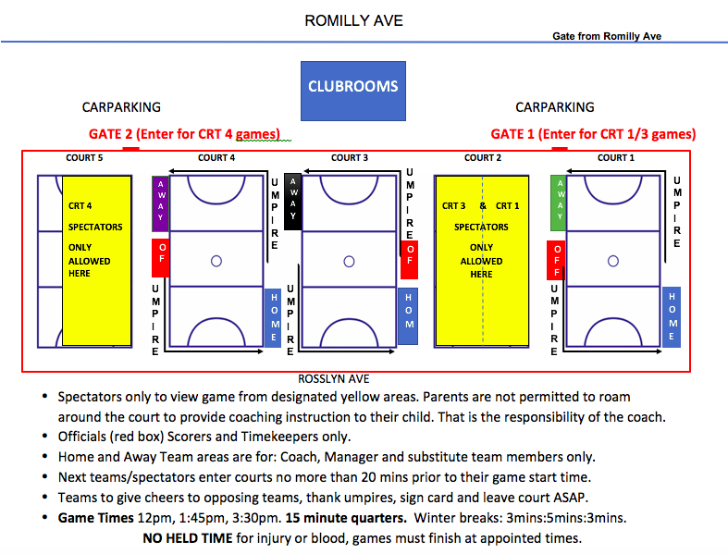

On the Court (SUMMER)

COURTS
Association games are held at SAUCNA Central Courts, Corner of Anzac Highway and Goodwood Road, Adelaide.

Home Team Duties:
In the first game time of the night, the home team will get pole covers from the store-room behind the canteen. After the last game time of the night, the home team removes the pole covers and returns them to the storeroom (if it is the final game on the court).

PLEASE note, sometimes the first or last game on a court is in the middle timeslot – score card can be marked with a note to put away the pole covers.
The fine for failing to put away pole covers is $55 per court.

A contrasting set of bibs are in the kit bag. The rules state the home team should be the team to change if necessary.

Court Time
Across minor rounds we expect players to receive equal court time, assuming they are fit to play.

During major round matches:
Youngest teams (U8-U13) will receive a minimum of two quarters provided they are fit to play.

High division junior teams (U15-U17) can be guaranteed one quarter of game time according to the following criteria:
- player ability and performance
- experience, reliability, training attendance
- ability in positions played
- position required in the game and opposition teams’ skills.

Open teams would still be expected to meet the minimum one quarter, but as adults can come to their own arrangements through discussion within their teams.

The club and coaches will need to communicate these policies with players and parents up front. Please ensure clear and open discussion with all parties, including the parents of junior players, and club management (if required) to clarify decisions re playing time, and especially so, during finals.

Fill in Players – minor rounds

A “Fill in Player” can play when the number of usual team players is insufficient in minor round matches. (refer to St Monicas Netball Club Policies.)

- can be players from lower grade/division (max 4 matches only). If the fill in player plays 5 games “up”, they will be unable to return to their registered team (refer to SAUCNA PLAYING CONDITIONS).
- Must be registered using PLAYHQ prior to the game. Failure to register beforehand will result in a fine to SMNC and potentially, game forfeit result.
- Must be from the same or lower division in SMNC
- Can be a player new to the competition
- CANNOT be a current registered player from another SAUCNA club
- CANNOT be older for the age competition (up to and including 31 December)
- Ensure adequate time has been provided before the game to enable the player to obtain a uniform.
- It’s always best to get advice about who is suitable from the Management Committee.

Finals Matches

All players must have played at least 3 matches for their registered team to be eligible under SAUCNA rules. Teams should not play anyone, not a regular team player, without discussion with the SMNC Committee.
Permission to play another player can be requested by application to the SAUCNA Season Subcommittee.

Should a team have only 7 players available for a major round match (due to injury, illness or unavailability), a player who has played at least three minor round matches in a lower team may be eligible to play, provided approval is gained from SAUCNA.

If prior approval has not been obtained, the game may result in forfeit due to infringement of the rules.

FORFEIT
If you are unable to field a team with at least 5 players, and wish to forfeit the match, please contact Judith via email stmonicasnetballclub@hotmail.com prior to 12pm game day or via text message on 0404 032 359 after 312pm to allow time to advise the opposition and umpires of the forfeit. Failure to provide timely notification will result in a fine to SMNC of up to $80.

REGRADING
After the 4th round of games teams can be “regraded”. The draw will change and home and away times may also change.

RESULTS
All results must be entered into PLAY HQ ASAP. Ensure that early in the season that parents are familiar with the results entering process early in the season. Also note the opportunity enter their nominations for most valuable player can occur at the same time. Ideally this occurs right at the end of the game.

If results are not entered, or players are not selected per game, we may receive a fine.

Score Cards and Scoring
Score cards are to be completed by the nominated scorer as per the SAUCNA playing rules: - refer to Score Card in the document.

The “Home Team” has the white card, and the “Visitors Team” has a blue card – the white card is the official card and the score of the white card is the score that will be recorded if there is a dispute.
- Both cards must contain the full name of each player, positions played each quarter, the score at each quarter, scorer name (printed), signatures and names of umpires (as below).
- Following the game, the team manager will enter this information into PLAYHQ.

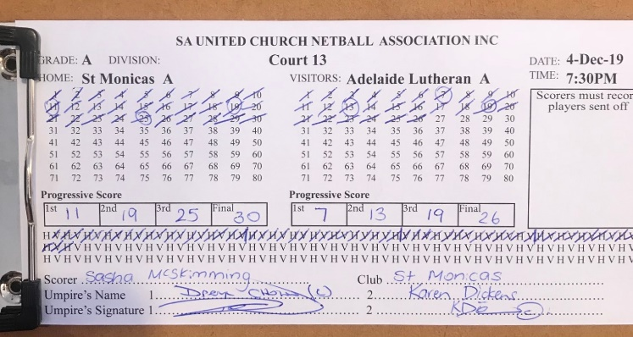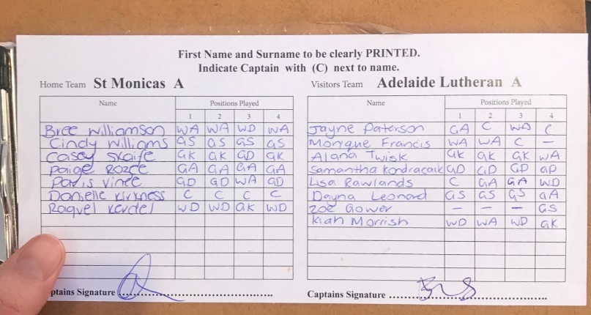

WINTER GAMES (Home & Away courts)
Scorecards are provided in the Coach’s pack and include white cards for home games, and blue cards for away games. The white card, completed by the home team, is always considered the official card. In the case of an unresolved score discrepancy, the result of the white card will be the official result.

SUMMER GAMES (Association Courts)
Score cards are collected from the Official’s office at the courts on the night of the game.
The card has the information about the game already typed onto the card:

After the game THE CARD MUST BE RETRUNED TO SAUCNA OFFICE at the courts.

SCORERS
Scorers should always sit together and score without distraction from other spectators. It is necessary that both scorers check their scores and centre passes are the same at the end of each break, or more often in fast scoring matches. Scorers also need to ensure their centre pass recording matches that of the umpires so check with them between breaks.

Most common issues with scorecards not correctly completed are:
- Full name of the players not recorded. Nick names used.
- Quarter by quarter position changes not completed.
- Quarter by quarter scores not recorded.
- Players entered on the card, who do not play.
- Officials of the game – scorers and umpires not legibly recorded on the card.

WINTER SEASON
Cards are to be returned to the SMNC clubrooms at the home courts for home games. A box for cards, and vote envelopes is kept just inside the door on the bench.

For away games, including games at the SAUCNA courts, cards, and vote envelopes, must be dropped off to the letterbox of 20 Romilly Ave, Manningham on Saturday, following the game. If there is any problem with a scorecard, please call Judith - 0404 032 359.

SUMMER SEASON
During Summer, and for finals held at the SAUCNA courts, score cards will be collected from the official’s office, and returned to the official’s office at the courts immediately after the game.

Bibs

Teams at the home courts may be asked to wear bibs of a distinctly different colour in the event the opposition has a similar uniform colour. Kits should include two sets of bibs in the event another colour is required, but if not present, they are available in the stationary cupboard in the clubrooms.

Umpires

All clubs provide an umpire for each game. It is likely that you are allocated a St Monica’s umpire for a season. Remember these may be juniors developing their umpiring skills (under supervision), a trainee (“Orange Armband”) or a current St Monica’s player. Other umpires are dedicated long standing members or supporters with a passion for netball and the club, who are volunteering their time so the players are ensured to have a game.

Take care of your umpires, and be respectful, as they belong to us. Many are young trainees so need support not criticism! Please take the time to introduce players and parents to your umpire at the beginning of the season. This introduction will greatly assist in the management of appropriate courtside behaviours

SUPPORTING RESPECTFUL BEHAVIOUR
At the beginning of the game, ensure that all players and parents are aware they are expected to positively support the teams and umpires. It is important that at the beginning of the season you remind players and spectators of acceptable court behaviours, which includes reminding them to keep their comments to themselves, as audible comments about the umpire/umpiring will not be tolerated.

Inappropriate comments or criticism reflects poorly on the club and its families, and discourages others from having a go at umpiring. Coaches, managers, and spectators are expected to abide by our club Parent and Spectator Codes of Conduct, under SMNC policies and SAUCNA – Code of Conduct policies:

A concern about umpiring matters can be raised in two ways.

- As per the rulebook:

- The captain has the right to approach the umpires during an interval for clarification of any rule, by asking an appropriate question: “Is it X rule if the player does/is doing …..?”
Any player/s for whom the clarification is relevant may accompany the captain. The umpires may request the captain to speak to any on-court player/s whose behaviour is causing concern.

- Common sense will dictate that the team coach or manager will accompany a young captain in junior aged games to talk to the umpire, to listen to the answer to help with the interpretation.

- At the city courts, concern about umpiring during the game can be responded to by attending the Official’s Room and asking for an Umpiring Supervisor to attend the court. For any inappropriate sideline behaviour (Coaches/Managers/Parents) this can be raised during the game at the Official’s Room by asking for a Court Supervisor.

- By raising concern with the club management.

Court Behaviour

The coach is the only person designated to make comments that direct team play. Parents may need to be advised that it is not their role, and it is not acceptable, to provide coaching advice from the sidelines. They are expected to sit quietly, and may clap or make comments that reflect on play, such as:
- “Good Pass”
- “Nice try”
- “Good Goal”
Spectators are expected to avoid making any comments that may be considered disrespectful or derogatory towards other people, players, coaches or umpires.

All parents can get caught up in the moment, and can be very loud on the sidelines. Coaches should remind parents that many people all trying to coach can be a distraction to their ideas and planning, and prevent players from hearing what their coach has to say.

Parents from Home and Away teams who fail to follow instructions from officials will be asked to leave the court area.

Incident Reporting
Incidents at matches related to umpiring, conduct or other irregularities should be reported to the club: stmonicasnetballclub@hotmail.com. The complaint will then be discussed by the Club or with SAUCNA, depending on the concern raised.

Serious incidents should be reported directly to the SMNC Secretary: stmonicasnetballclub@hotmail.com, as quickly as possible. Such reports will be collated and sent to the SAUCNA Complaints Board Member from the club secretary.

Codes of Conduct
Netball is a fabulous and exciting game, and sometimes it can be difficult to keep one’s emotions in check. Ultimately how we talk and interact with each other has a huge impact on the morale of the players, coaches, managers, umpires and families, and the reputation of our Club.

To provide the optimal environment for our players, St Monica’s Netball Club, and SAUCNA, abide by Codes of Conduct. Please ensure you are familiar with these, and bring the policies to the attention of all players and parents so they understand what is expected of them in the netball environment. You can find the codes of conduct here, which include:
- Player Code of Conduct
- Coaches Code of Conduct
- Spectator Code of Conduct and SAUCNA Spectator Behaviour Policy
- Parent Code of Conduct
- SAUCNA Discipline procedure

Supporting positive team behaviours
Coaches have found it useful to have a conversation with the players about behaviours that can happen on and off the court, and to share the behaviours they find supportive (eg cheering, encouragement, doing the team shout) and to identify, behaviours or actions that interfere with their playing (eg. name calling, taunting, unnecessary physical contact).

Identifying positive, or ‘above the line’ behaviours, and those they do not like to experience (called below the line behaviours) helps the team to create an understanding of how they expect to treat each other, and to be treated by others.

A team charter might look like this:

Supportive of the decisions of players, coaches and umpires
Reliable and on time
Accepting of ideas and feedback that helps us improve our play
honest
Listening and speaking respectfully
When we show our best selves we are:
accountable for our behaviour on the court
able to ask for help
responsible for our emotions on the court

Argue with umpires, coaches or other players
Be disrespectful of decisions made by umpires or coaches eg eyerolls, talking behind their back
criticise, bully or be unnecessarily physical to other players
Take feedback personally
We agree not to

This conversation then can lead to the ‘what do I do next’ question.

Once the behaviours are identified, encourage the team to talk through situations that can occur in the netball environment, and discuss what they, and others can do to respond or prevent poor behaviours. The coach can reinforce the importance of focusing on the game, and what it means to be both a competitive, yet professional player. By being ‘their best selves’ on the court, smiling, not reacting, ignoring taunts, not taking criticism personally, accepting criticism or feedback about performance in the game as a learning experience, or reacting to the poor behaviour of others, the opponents’ game will suffer the most.

Players can bring concerns about behaviours to the attention of their coach or team manager, who can then help them to manage the situation. ‘On court’ concerns about behaviours of players, team mates, or spectators should be discussed with the SMNC Executive Committee.

Whatever a team behaviours list or team charter looks like, it is important this list is shared with care givers. Encourage them to have conversations with their children about how to manage inappropriate behaviour, and use the opportunity to remind them about the parent and spectator code of conduct. Schools have similar conversations and expectations about how to prevent and manage bullying so the concept of identifying positive behaviours, and challenging unwanted behaviours should not be new. As children are learning life skills, they are just as relevant outside of school, and we have opportunity to reinforce professional behaviour and sportsmanship.

Sportsmanship has been variously described as:
- an understanding of and commitment to fair play, ethical behavior and integrity, and general goodwill toward an opponent
- an affirmation that an athlete is disciplined enough to have perspective, maintain poise and do what is best for his or her teammates.
- an aspiration or ethos that a sport will be enjoyed for its own sake, and with proper consideration for fairness ethics respect and a sense of fellowship with one's competitors.

Inappropriate behaviour will not be tolerated by the club. While we are confident that our volunteers understand and ascribe to our values, we do not consistently see this courtside, so this section has been added to provide some guidance and support to help reinforce how as a Club, we wish to play our sport. If you have concerns about behaviours or incidents, please raise with the St Monica’s Executive, and we will assist you to resolve concerns

A Team Behaviours template is enclosed at the end of the document if you wish to use one. If you require assistance to have this conversation with your team please contact stmonicasnetballclub@hotmail.com .

COACHES RESPONSIBILITIES

Child Safety – Coaches and Managers

The St Monica’s Netball Club is committed to the provision of a child safe environment. Children are those members under 18 years of age.

We collect information about our coaches via the online PlayHQ Coach or Manager Registration Form: https://www.playhq.com/netball-australia/register/c19bf5

We monitor all those involved with children, for the safety of everyone involved with our club, requiring all those working with children have their Working with Children Check. This check has been a requirement since 2019. We also encourage coaches to complete the Play by the Rules child protection courses.

In South Australia since the 1st July, 2019, you must have a Working with Children Check, WWCC, if you work with children. This includes those volunteering in roles in sporting clubs. Conditions include:

- Parents who volunteer with their child’s team are not required to complete a check, nor those who have contact with children for 7 days or less in a calendar year. Although the process is free and as a club we encourage as many coaches and managers to hold a valid WWCC as a higher level of compliance.
- Workplace WWCC are valid for those volunteering at St Monica’s Netball Club. If you have a current WWCC please provide evidence to stmonicasnetballclub@hotmail.com for our records. WWCC are valid for 5 years.
- WWCCs are free for volunteers. If you currently don’t possess a WWCC we can initiate the process for you.
- Should you become aware of any concerns about the welfare of any child, please report your concerns to the club. Our club and members are compelled to report any suspected form of child abuse to the appropriate authorities under mandatory reporting obligations.
- If you are a mandated reporter in the course of your profession follow your guidelines, however please also advise us of your intention to do so as a courtesy.

If you believe a child is at immediate risk call SAPOL 000, or 24-hour Child Abuse Report Line “CARL” on 13 14 78.
Our committee members, and several coaches and managers, have specialist child safe training and expertise we can draw on should such an incident arise.

team Organisation & Management

- Your key point of contact with children will be through the parents. Private messaging directly to children should not occur.
- Coaches and or managers will be provided with a list of emergency contact numbers for each team member.
- Some teams use an app to assist team communications as not everyone has ready access to email. What’s App is efficient and commonly used for team communications and congratulations.
- Managers and coaches are best placed to set this up on behalf of their team, and closing the group at the end of season.
- Coaches with Team Managers often share the responsibilities needed to keep the team informed.
  - Coaches are best placed to spend their time designing their coaching plans manage training processes, and are responsible for team positions during the game, for example.
  - Team Managers generally take on the administrative responsibilities, being the first point of contact for parent queries, sending reminders of training and game times, rostering scorers, timers, team captains and BBQ responsibilities (during winter), replacing First Aid items, and managing voting slips, for example.
  - Familiarity with SMNC internet and Facebook pages will assist both to gain knowledge of the Club.

Primary Care Giver
The Manager or the Coach or another parent can assume the role of the “Primary Care Giver” as designated in the official rules of netball. Each team bag has a lanyard and attached card indicating the wearer is the Primary Care Giver.

In the event of an injury, the Primary Care Giver can enter the court to assess the player, assist them off the court, or advise the umpire that it is unsafe to move the player due to the seriousness of the injury.

Players have 30s if time is held for blood or injury, and must leave the court to receive treatment, unless they are unable to do so.
The umpires must accept the decision of the Primary Care Giver that a player should not be moved before professional assistance arrives.

Working with Parents

General information
- Please encourage your parents to access the SMNC internet and Facebook pages for information related to the game, the club, our policies, necessary and interesting information.
- Our Facebook page is frequently updated with information that teams need to know on a very regular basis, and can greatly assist the need to contact the club directly.
- Parents are encouraged to support the volunteers of the club by using the resources available to them.

Training and games
- Encourage caregivers to ensure players arrive at training and games on time, so they don’t miss vital information and can properly participate in warm ups.
- If a player is consistently running late, and you have been unsuccessful at raising the issue with the person or their care giver, please raise the matter with the club.
- If parents are not remaining at practice or at the game, they must notify the coach of arrangements for their child in their absence.
- Coaches should not remain alone after practice with children – ask another parent to wait with you for the parent to arrive.
- Children should not visit the toilets alone.
- Where children require being accompanied to the toilet, ideally the child’s own parents will accompany their children.

Health & Safety
Member welfare is of utmost importance, as is the welfare of teams and spectators of any visiting club.

Knee program
For the health and safety of the players, please ensure your coaching practice includes knee care. Teams should implement the “knee program” suitable for their age and level of development at each training and games as a part of their standard warm-up. https://knee.netball.com.au/

First Aid
All team bags carry first aid kits.
Kits include the most commonly required first aid supplies, including gloves for infection control and instant ice packs, for use at away games.
Supplies can be replenished from the stationary cupboard in the home clubrooms.
The home clubroom has an AED defibrillator complete with adult and child sized pads. The defibrillator is designed to be used by anyone with programed instructions that guide use.
The freezer in the clubrooms also carries ice in snaplock bags, and some reusable cold packs.

Concussion
SAUCNA Concussion Policy will be implemented for Winter 2022.

Concussion is a serious neurological disturbance and can have lifelong consequences for those affected. Many teams are using HeadCheck to assist teams to identify risk and injury. This is an Australian resource designed to initially assess and manage suspected concussions courtside:
https://www.headcheck.com.au/

All teams will have a role to play in watching for and responding to suspected concussion events. Ideally, Team Managers, coaches and some parents (especially those with a health/medical background) would be advised to download Headcheck to their smart phone, and understand steps to take in the event of a suspected head injury.

Like any serious injury on court, moving an injured person should only occur if it is safe to do so. Matches can shift to other courts, or if necessary be abandoned to ensure an injured person receives appropriate care. Court supervisors are available to assist decision making, however should an ambulance be required, call one.

Insurance
Players, and officials are covered by insurance paid by clubs. Claims for non-Medicare related costs can be made. These include: physiotherapy, chiropractic treatments, ambulance, dental, private hospital costs, loss of income.

Forms can be obtained by emailing: stmonicasnetballclub@hotmail.com
All serious injuries should be reported to the Secretary at the above email address.

Club Awards

INDIVIDUAL TEAM AWARDS

There are usually two awards offered for each team at the end of the Winter season – Best and Fairest, and Team Player Awards.

BEST & FAIREST PLAYER

Best and Fairest is offered from U9 to Opens Teams. This is awarded to the player who receives the highest number of votes over the winter season.

- How to cast the votes is to be decided by the coach/manager at the beginning of each season.
- Votes are cast each week for the top three players using the voting slip and envelope provided in the Team Kit.
- Some coaches / managers choose to ask umpires or coaches of opposing teams before the game starts, to place the vote, as this practice will ensure objectivity and avoid bias. Make sure these are collected at the end of the game. This role is often allocated to the Team Manager.
- The voting slip requires the name of the player and their position. The Team Manager should clarify the correct individual was selected, as the players may change position during the course of the game.

Voting occurs in this way

- 3 Votes (the best player)
- 2 Votes
- 1 Vote

The sealed voting slip is to be sent back to the club with the score card, where a member of the committee will tally the results each week.

Open teams may choose to decide these trophies in other ways.
A1 and 2 players are also eligible for SAUCNA best player awards:
A1 – The Joy Smith Award
A2 – The Kevin Beare Award

TEAM PLAYER
Team Coach will nominate one player from each team who has demonstrated club values, commitment, skill improvement and a passion for netball over the season.
Open Teams without a coach can decide this trophy via their own MVP system.

PERPETUAL TROPHIES
At the end of the winter season, the Club will call for nominations for all of the St Monica’s Netball Club Perpetual Trophies. All nominations will be accompanied by a detailed description and statistics justifying the nomination. Details regarding how to nominate for the awards will be posted prior to the end of season.

The Awards are:
Under 11 MARGARET MARLOW JUNIOR ENCOURAGEMENT AWARD
Under 11 coaches to nominate a player from their team who has shown great skill, a passion for netball, great sportsmanship and a desire to develop themselves by listening to the coach and always encouraging others.

YOUTH INITIATIVE AWARD
This award recognises a young individual in our club or community who has made a significant contribution to the club.

SENIOR ENCOURAGEMENT AWARD – SUBURBAN COURTS
All U13 and U15 coaches are invited to nominate a player from their team informed by your assessment of their:
- skill and growth over the season
- passion for netball
- great sportsmanship and
- a desire to develop themselves by listening to the coach and
- always encouraging others – being a genuine team player
- of the expected values and behaviours of St Monica’s netball Club.
SENIOR ENCOURAGEMENT AWARD – ASSOCIATION COURTS
All U17 and Open coaches are invited to nominate a player from their team who has shown:
- skill and growth over the season
- passion for netball
- great sportsmanship and
- a desire to develop themselves by listening to the coach and
- always encouraging others – being a genuine team player
- demonstration of the expected values and behaviours of the SMNC

DIGNAM DEFENDER TROPHY – SUBURBAN COURTS (U13 & U/15)
This award is for the most outstanding U13 and U15 player. These players have demonstrated most capability in their defensive skills, and have as shown significant improvement in a defender position on court. These players have also demonstrated good sportsmanship, demonstrating the expected values and behaviours of the St Monica’s Netball Club.

DIGNAM DEFENDER TROPHY – ASSOCIATION COURTS (U/17)
This award is for the most outstanding U17 player. These players have demonstrated most capability in their defensive skills, and have as shown significant improvement in a defender position on court. These players have also demonstrated good sportsmanship, demonstrating the expected values and behaviours of the St Monica’s Netball Club.

VAL MUIRHEAD GOAL THROWING AWARD (U/13 and above)
This award acknowledged the most accuracy in their goal shooting, representing the Highest Goal Statistics over the winter season. To ensure this happens the Committee requires evidence of a players shooting statistics. There is a template in the Coaches booklet to enable recording of goals and attempts. Ask someone involved with the team to take responsibility for recording goals at the beginning of the season, and to complete the booklet every game. Coaches keep the booklet and submit to the committee at the end of the season.

The information is recorded as goals in + misses = attempts. An additional attempt is not awarded if a contact or obstruction occurs, and a free is awarded).

Wishing you and your team a fabulous Winter Netball season!

TEAM BEHAVIOURS TEMPLATE (opt)
(Insert TEAM NAME)
We agree not to
When we show our best selves we are:

